**For Loop**

This document will explain how to use For Loop.

Please go through the following sample automation **For Loop. Zappy** file.

**Step 1:** Right click on Zap icon and select Task Editor (or Double click on zap icon).

**Step 2:**  Open **“For Loop. Zappy”** file.

**Step 3:** To start the execution click on .

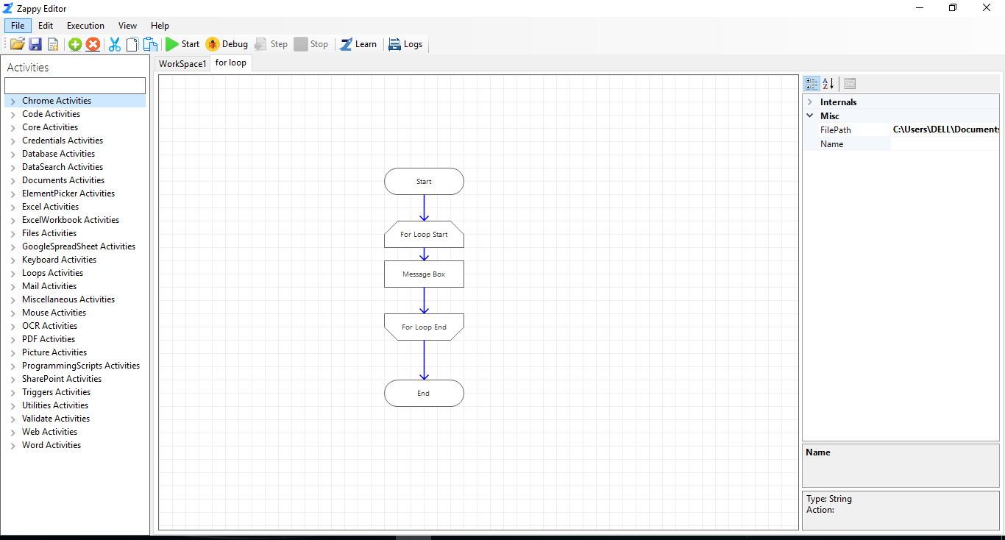

**Output:** Output will be show on message box then you click on **OK**.

